Entries for the WJEC Foundation Excellence Award Exhibition
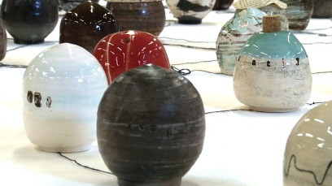
Rosemary Bettles
Pathway: 3D Art & Design
Ceramics
Artist’s Statement:
‘Concealment’
I have been looking at how people conceal personal matters, such as secrets, thoughts and private issues.

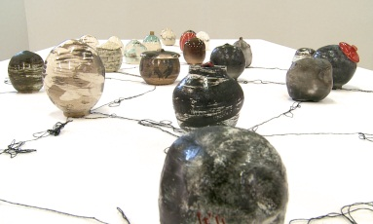
My goal was to create a series of ceramic vessels into which are placed written issues that are personal to me, and to capture the viewer’s imagination without revealing the secrets.

I intend the work to be interactive with the viewer being able to see or read sections of text, but I have coded or scrambled the words and developed symbols to create a language comprehensible to me alone. The viewer is not able to read every word or understand the secret which is personal to me.

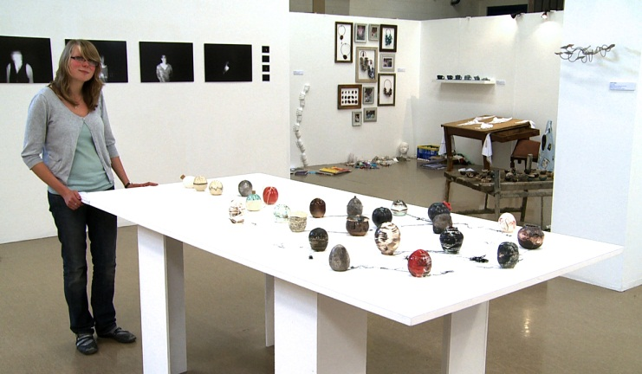

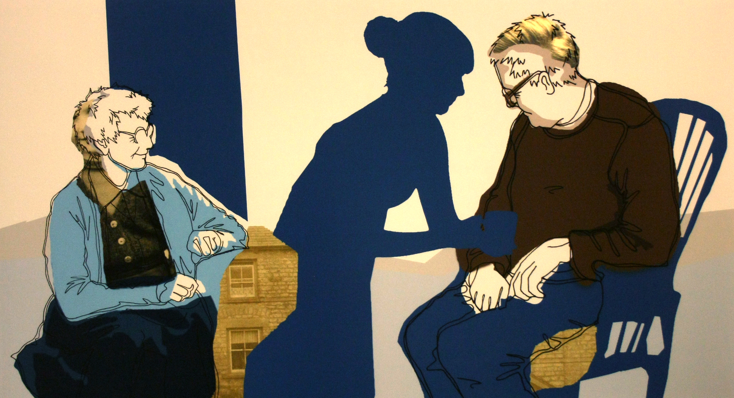
Eleanor Gray
Pathway: Visual Communications & Lens-based Media – Visual Communications
SA6
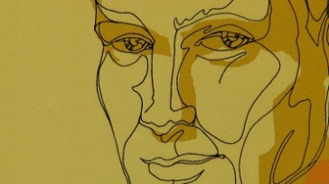
Artist’s Statement: ‘Space Between Memory’
In this project I wanted to explore the space between someone and their memories, and the idea that objects can trigger these memories. I reconstructed my grandparents’ living room in order that the viewer could interact in a tactile way with the objects placed there.
I took photographs of myself interacting with a collaged digital image of members of my family which I projected into a large space.
Through physically manifesting a memory using light, and through my interaction with it, I hoped to represent the ethereal nature of memory, because memory is as intangible as light.
I was interested how upset I became during my interaction with the projected image, and feel this made the resulting images more personal and emotive.
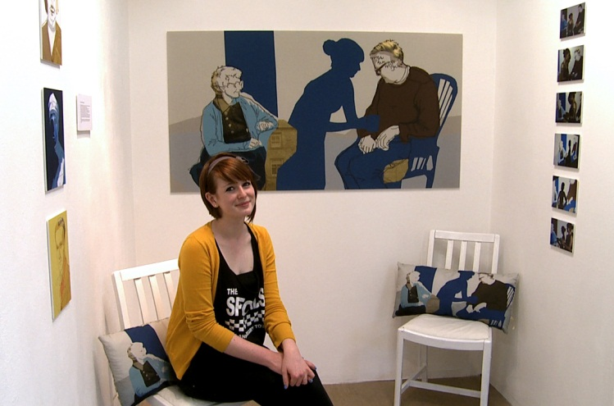

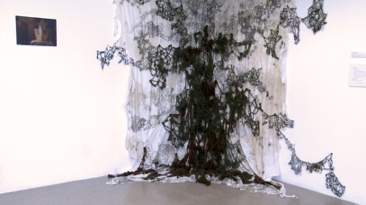
Canan Ozyurt
Pathway: Fashion and Textiles

Artist’s Statement: ‘Growth in Domestic Spaces’
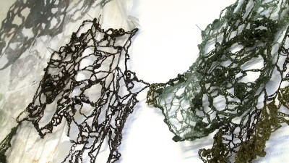
By observing aspects of house cleaning and what we clean, I have investigated household stains and the growth of moulds. This led me to explore the different patterns, shapes, lines and forms that may be formed by accidental spillages.
My intention with this piece was to visually break stains and moulds apart and use the forms I found to construct something aesthetically pleasing, inspired from a source material generally considered to be unattractive.
I hoped to create something that is unappealing from a distance, but which on closer examination holds many fascinating structures, textures, patterns and forms.

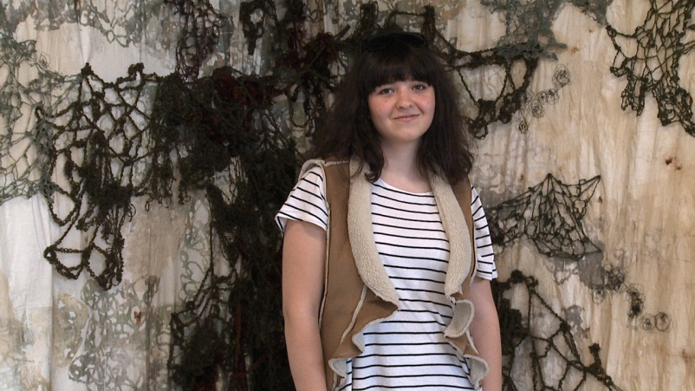

Guto Morgan – Pathway: Fine Art & Illustration - Painting
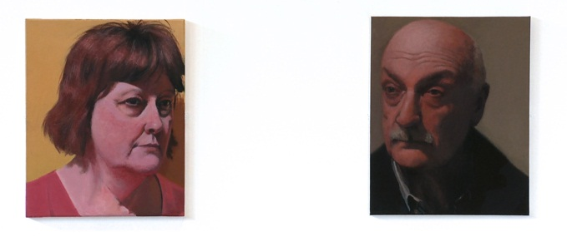
Display Information: Guto’s work includes 4 canvasses measuring 41 cms x 51 cms
Artist’s Statement: ‘Alleviation’
My body of work is deeply autobiographical. I intend to convey how trivial, common arguments cause unnecessary distress. My initial investigation will look into priorities, happiness and perspective where significance can be conveyed through placement of objects or events within the pictorial field.
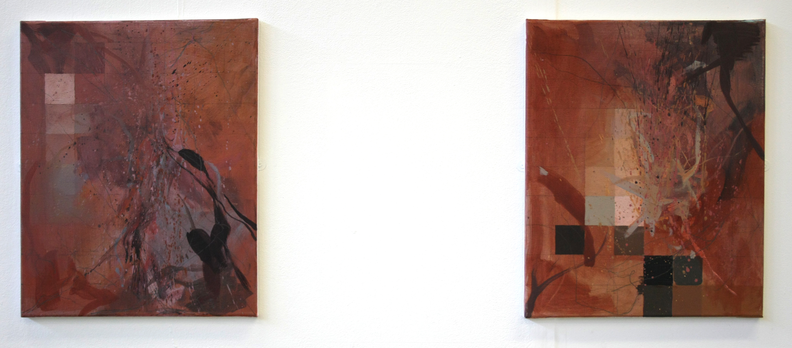

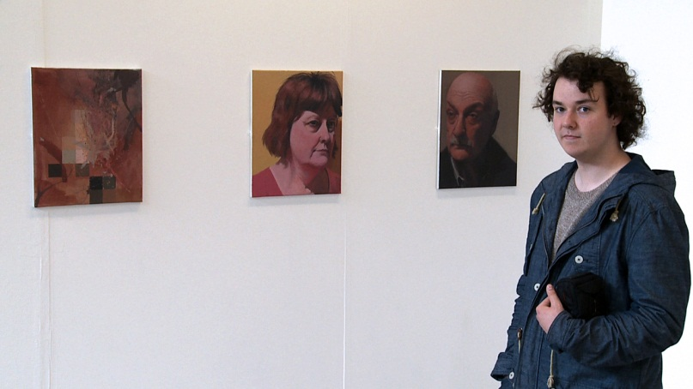

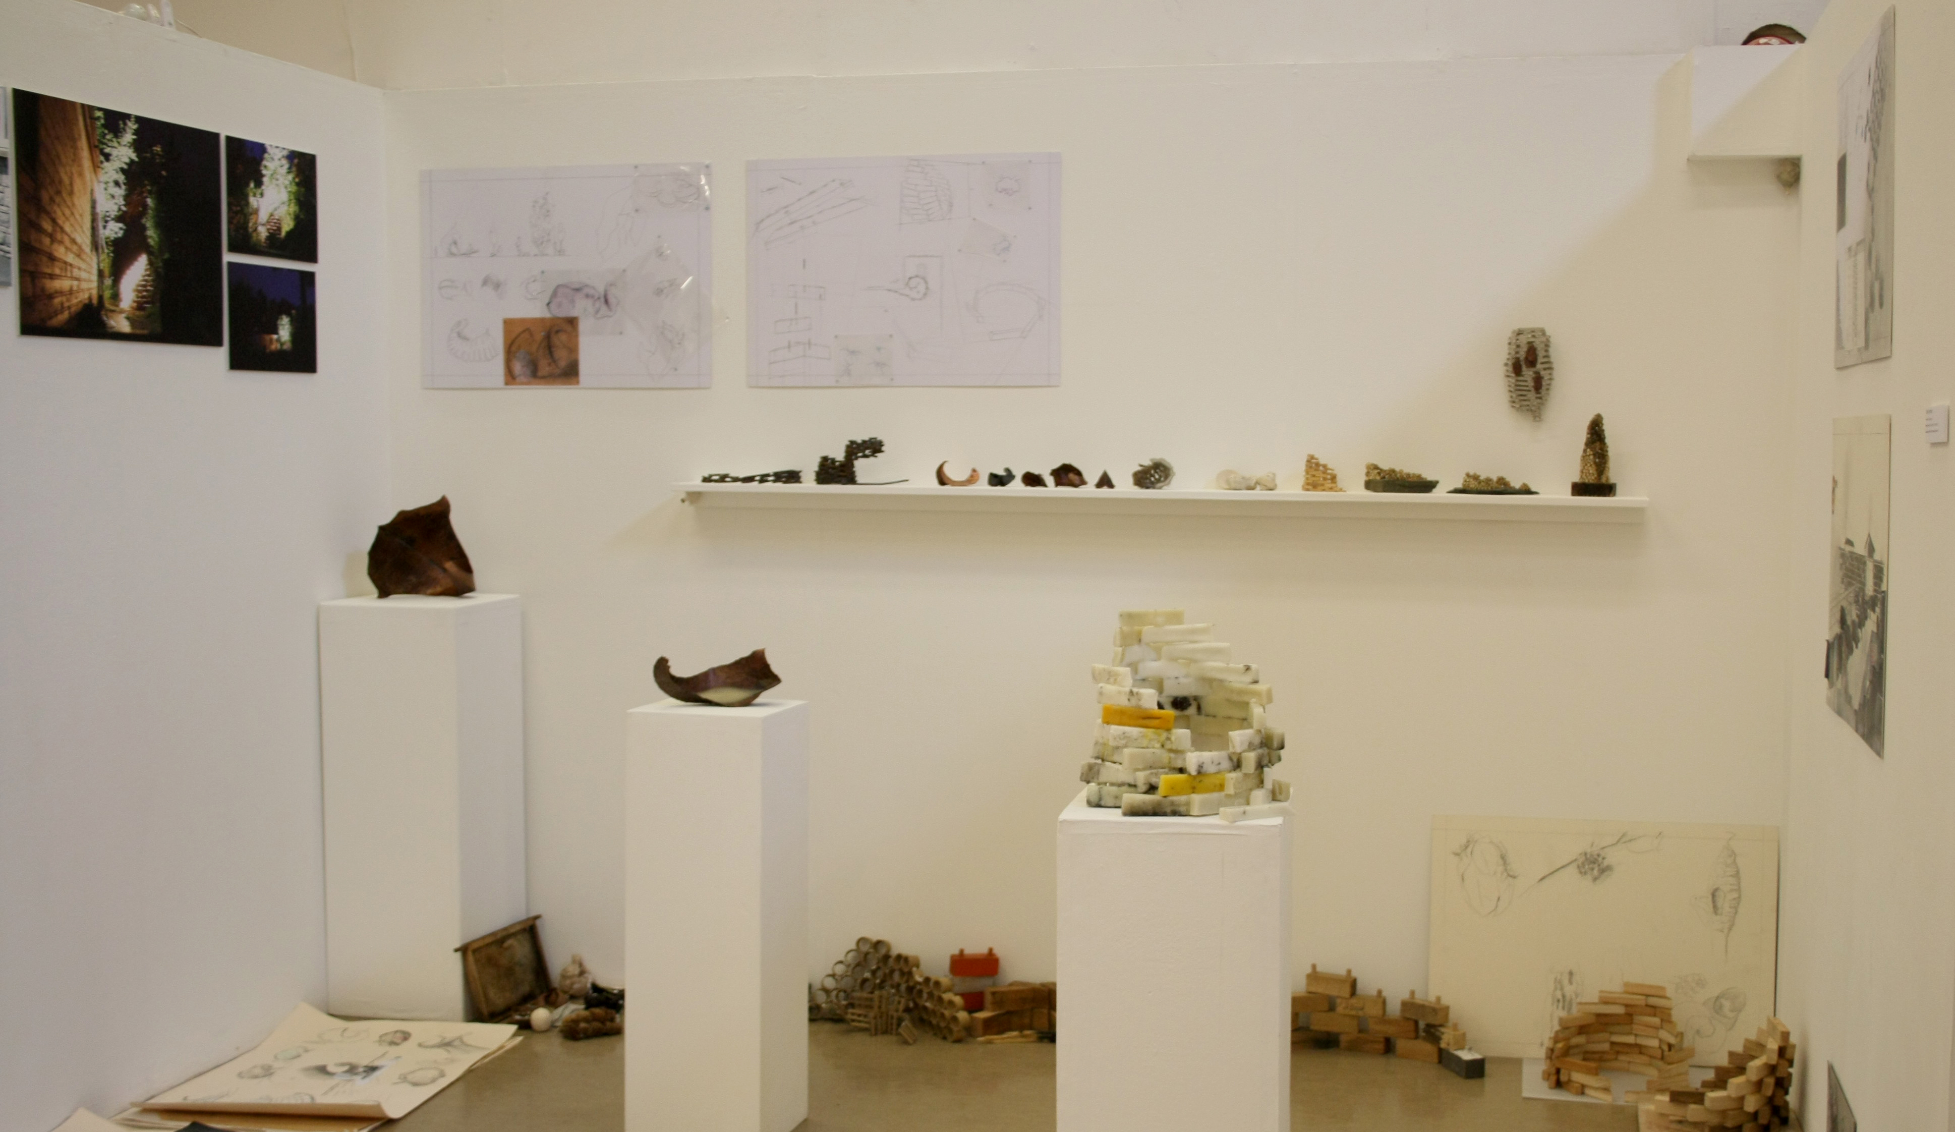
Osian Denman - Pathway: 3D Art & Design
Display Information: Osian’s work includes a range of small-scale maquettes and larger 3D pieces together with A1 and A3 size 3D design sheets and photographs. The maquettes are displayed on a long slim shelf measuring 17cms x approximately 8ft. Three sculptures are each displayed on white plinths.

Artist’s Statement: ‘ Architectural Intervention’
My goal was to produce an exploratory body of work that looks at how we can be influenced by structures, bio-mimicry, and housing solutions of animal and insect dwellings.
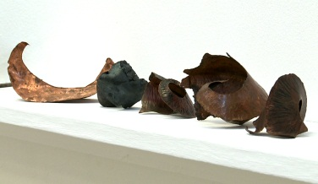
I am particularly interested in the use of forms made from repetitive processes employed by insects and birds in the construction of their dwellings, and combining their influence with new design and build techniques.

